OA99+ manual
1、Appearance
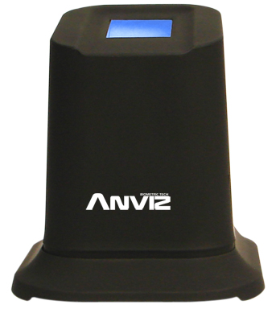
2、Parameter
Image format | 304×256 BMP | 500dpi
System power supply | 5.0V
1:1 Identification | ＜20ms | Feature capture＋fingerprint comparation
1:5000 Identification | ≤1s
Image load times | 15fps
FAR | <0.0001%
FRR | <0.001%
External port | Standard USB port
Sensor size | 24×25×55mm
Reader size | 68x75x74mm
External Interface | Standard USB port
3、Connection illustration
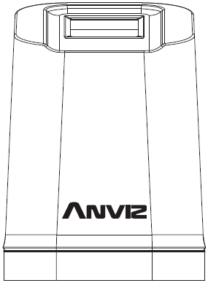
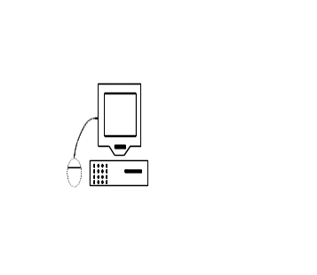

USB port Communication

